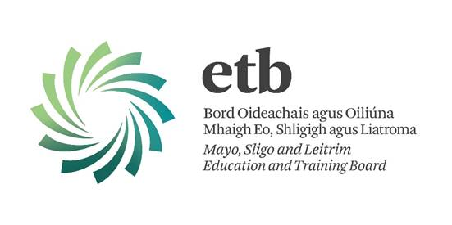**College/Centre Withdrawal of Consent Form**

**Details of the Controller (College/Centre):**

|  |
| --- |
| This request is made to: |
| **Davitt College** |
|  |

|  |
| --- |
| Address of Controller (College/Centre) named above: |
| **Springfield,** |
| **Castlebar,** |
| **Co. Mayo F23 VY15** |

**Details of data subject:**

**I am a:**

* Parent/Guardian
* Learner (over 18 years)

|  |
| --- |
| My Full Name: |
|  |
| My Address: |
|  |
|  |
|  |
| Contact Number: |

|  |
| --- |
| Name of Data Subject (Learner): |
|  |
|  |

**For the purpose of proving my identity, I attach a Garda verified copy of 1 of the following:**

* Passport
* Birth Certificate
* Driving License
* Recent utility bill

**Details of my request**

I ________________________ [*insert signature of Parent/Guardian/Learner over 18 years*] **wish to withdraw my consent** (under section 71(3)(C) of the Data Protection Act 2018) thatphotographs and video footage of ________________________ [learner’s name here] may be taken and used by or on behalf of **Davitt College** to promote its activities (currently and in the future) in the following circumstances; as selected by me:

|  |  |
| --- | --- |
| ***Photographic Image and/or Videographic footage of the learner for the purpose of:*** | |
| ***Please tick the use for which you wish to withdraw consent*** |  |
| On **Davitt College’s** website, and/or **MSLETB’s** website, social media and any other online publication associated with **MSLETB’s** colleges / centres / programmes / services. |  |
| Given to third parties, with the learner’s name, for the purpose of being used in print media *e.g.* newspapers, magazines, brochures / leaflets, posters, prospectus, reports books and other similar publications, *e.g.* a learner attaining top results in their course/apprenticeship/traineeship. |  |
| Displayed within the college/centre and including the learner’s name *e.g.* an image of a learner awarded the highest result in his/her course with his/her name below. |  |
| In college/centre yearbooks with the learner’s name also used. |  |
| For promotional purposes related to the college/centre *e.g.* college/centreprospectus or a video of a college/centre production. |  |

|  |
| --- |
| **Signed:** |
| **Printed Name:** |
| **Date:** |

**Please return this form to**: the relevant FET centre/college/ETB/Data Protection Officer.

**Note**: we require proof of the applicant’s identity to ensure that the person making this request is acting legitimately within sections 91(3) or 92(5).

|  |
| --- |
| **Request ref no.:** |
| **Date request received:** |
| **Proof of identity provided:** |
| **Any other relevant comments:** |
|  |

**Office Use Only**